***EXERCISE 3 :STORED PROCEDURES***

**Scenario 1 :**

The bank needs to process monthly interest for all savings accounts.

* + Question: Write a stored procedure ProcessMonthlyInterest that calculates and updates the balance of all savings accounts by applying an interest rate of 1% to the current balance.

OUTPUT:

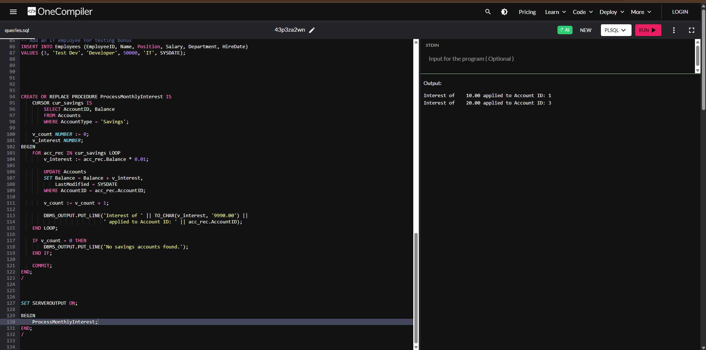

**Scenario 2:**

The bank wants to implement a bonus scheme for employees based on their performance.

* + Question: Write a stored procedure UpdateEmployeeBonus that updates the salary of employees in a given department by adding a bonus percentage passed as a parameter.

OUTPUT **:**

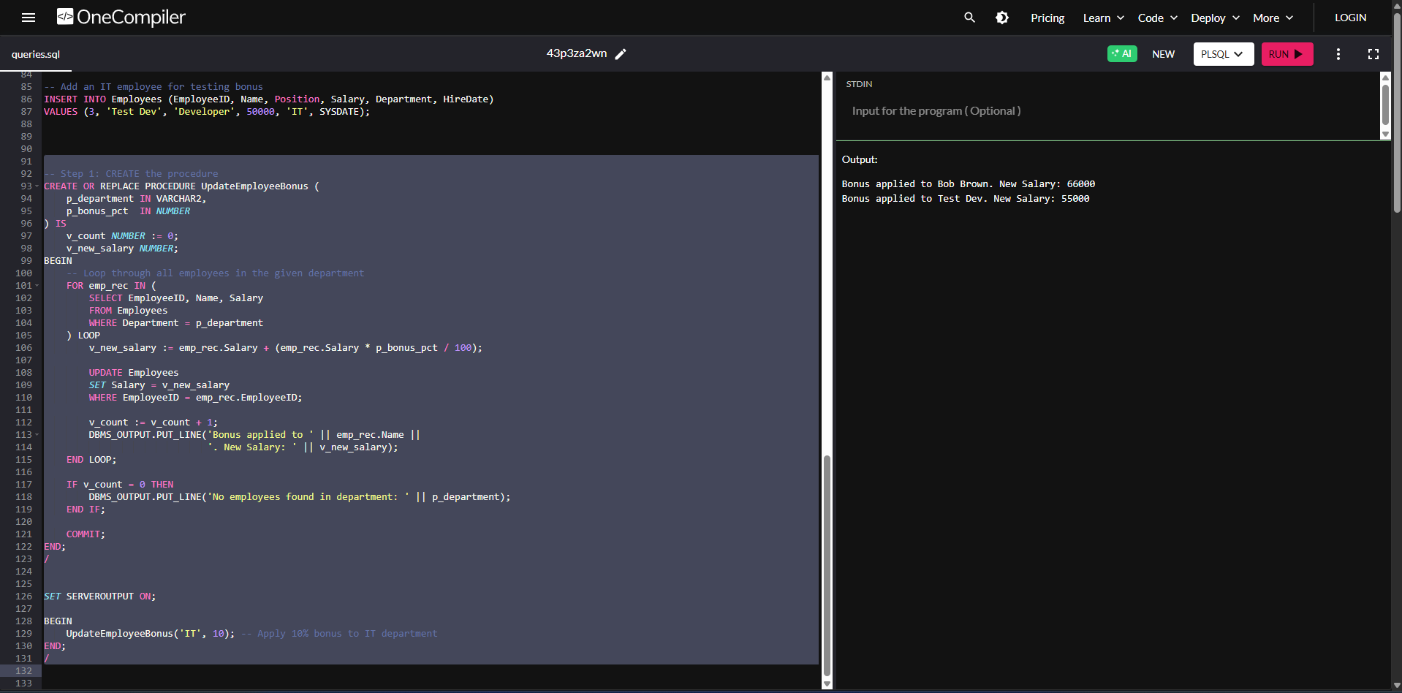

**Scenario 3:**

Customers should be able to transfer funds between their accounts.

* + Question: Write a stored procedure TransferFunds that transfers a specified amount from one account to another, checking that the source account has sufficient balance before making the transfer.

OUTPUT :

